CRRO Corner February 2018
Introducing Protocol Builder
Gina Daniels

Writing a protocol can be a daunting task. The Boston University Clinical and Translational Science Institute (CTSI) is excited to introduce a new tool available to assist you in writing your study protocols! Protocol Builder is a secure, cloud-based technology that provides step-by-step customized guidance for developing research protocols.
This new protocol writing technology can help you write protocols that adhere to Human Research Protection Program and applicable regulatory standards in less time with less hassle. It provides a structured and guided experience that can assist all investigators, new and experienced, in developing a clear and complete protocol. Protocol Builder can be used for both biomedical and social behavioral research studies, and can be customized to many different types of protocols (observational studies, interventional studies, etc.). Once you select the type of protocol you plan to develop, the application automatically populates the sections of the protocol that need to be filled. You can auto-build your glossary, abbreviations, references, and appendices as you go. The application provides relevant tips and instruction for each section that you need to fill.
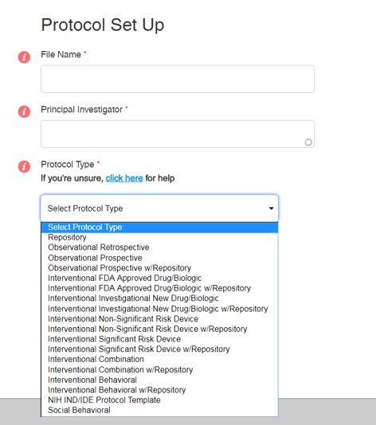
List of types of protocol templates available:

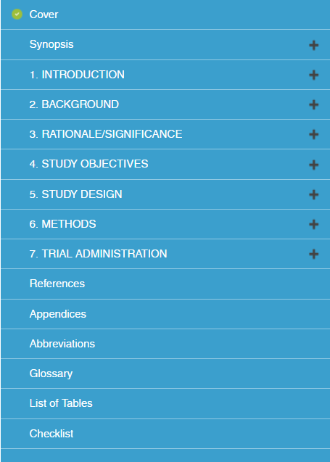
Sample list of sections to fill (ex: interventional behavioral study):

At any time during your drafting process, you can invite colleagues to review your protocol. Your colleagues can apply comments directly into your Protocol Builder document. Your finished protocol can be downloaded as a Word document or a PDF, and then you can upload it to your INSPIR application. Amendments and further modifications can be made to your protocol after your initial version is developed. Protocol Builder keeps track of recently made changes, from which you can automatically create a ‘Summary of Changes’ section for your amendment.
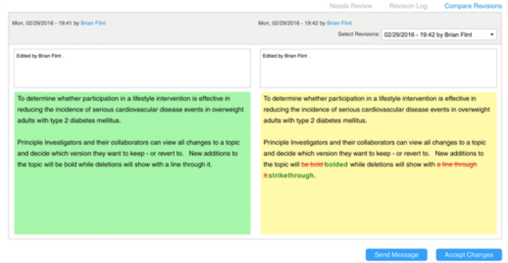
Protocol Builder is developed and hosted by Biomedical Research Alliance of New York (BRANY), which is the same group that runs the CITI Program trainings. Protocol Builder can be accessed via your computer or an iPad app. If you would like to learn more about how to use the technology, Protocol Builder offers Informational Webinars twice per month to anyone interested in the program. You can find more information about the webinar schedule, FAQs, and Protocol Builder features on the Protocol Builder website.
Want to get started with Protocol Builder?
To request access to Protocol Builder, please visit the BMC/BU Medical Campus registration page at https://app.protocolbuilderpro.com/register/boston-university.
If you have questions or would like to request assistance with Protocol Builder, please contact Mary-Tara Roth at mtroth@bu.edu.
If you have questions regarding access or technical issues, please contact Tasha Coughlin at tawatson@bu.edu.

