Online Informatics for Researchers Course User Guide

Thank you for taking the time to evaluate and provide feedback on the online course, Informatics for Researchers. This document will instruct you in:
- Creating a New User Account
- Accessing the Online Course
- Working through the Course Content
- Documenting and Submitting your Feedback
- Protocol for Completing Course Evaluation Components

Creating a New User Account
- Go to https://online-informatics.bumc.bu.edu/login/index.php
- Complete each field (note your username and password for future reference), then click the “Create my new account” button
- Open your email account and read the “BU CTSI Biomedical Informatics: account confirmation” message. Click on the link within the message to confirm your new account.
- You should now be on the Informatics course Self-Enrollment page. Click on the course called Informatics for Researchers 2014.
- You should now be on the Course Home Page.

Accessing the Online Course
Each subsequent time you login to the course:
- Visit https://online-informatics.bumc.bu.edu
- Enter your username and password under “Returning to this website?”
- Click the “Login” button and then click on “Informatics for Researchers” under the Course overview heading.

Working through the Course Content
Informatics for Researchers is an online course comprised of nine separate modules, each of which contains a combination of narrated lessons, exploratory and/or scenario exercises, supplementary/supporting articles and/or web-based tools, a glossary and opportunities to connect with others via discussion boards.

To complete the testing and feedback process, you must work through all of the modules, but you may do so in any order and at any time you wish, so long as you finish by the due date. There is no right or wrong way to work through the content – much of what we are interested in is how researchers use the content.

On the Course Home Page, you will find sections for each module. Each section is marked with a numerical icon and title, and includes links to the module content, discussion board, evaluation survey, lesson transcripts and lesson transcript upload area. See example below with red text added for instructional purposes:
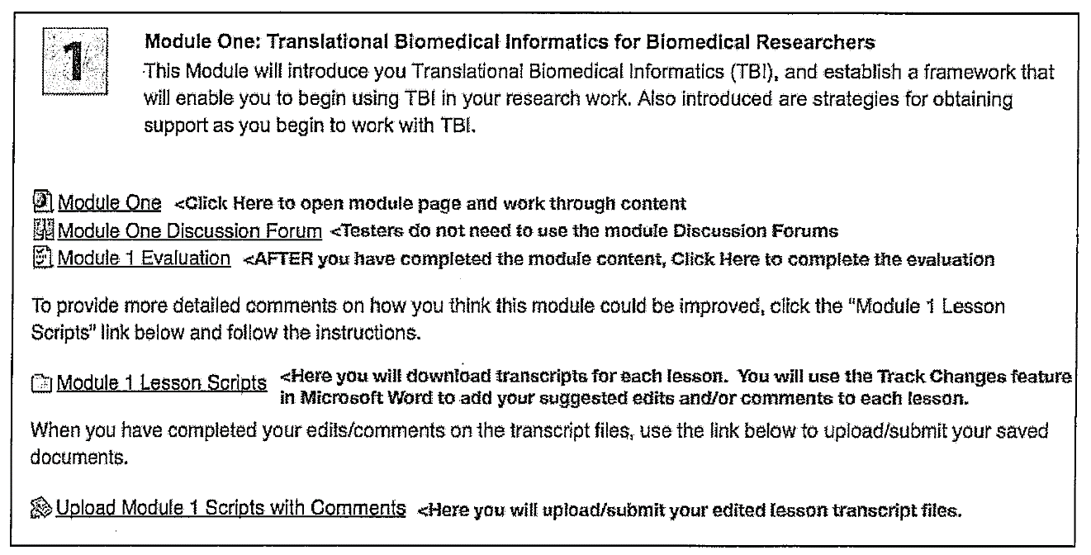

To work through the content for any module, start by clicking on the title link for the module page, e.g. Module One.

Once you open a module page, you will be able to work through the content as you like. You’ll find an Overview and Objectives to read, as well as a series of Lessons that you access by clicking on “Click to view” icons under each lesson title. See example below:
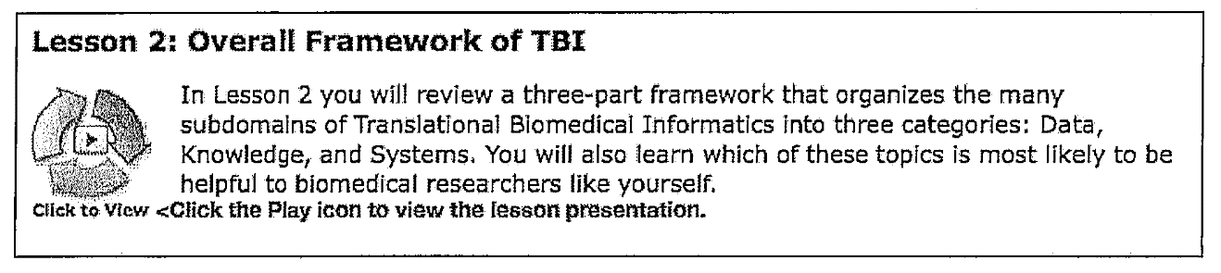

Many modules also contain Activities/Exercises interspersed among the Lessons. See example below from Module One:
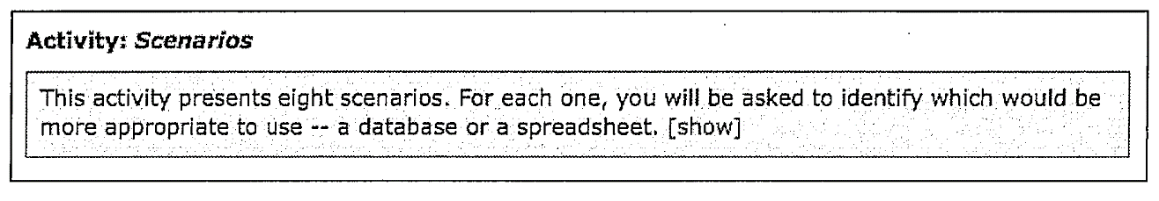
To access and complete each activity, click on the [show] link and follow the instructions.

Each module also contains an Extend section with a link to an Informatics Glossary and Additional Resources, which provide more in-depth information on the topic(s) covered in the module.

Each module also includes a Connect section. Please read the discussion prompt in each Connect section but do not post to the discussion boards.

Documenting and Submitting your Feedback
You will document and submit your feedback in a two-part process:

You will provide feedback for each module by:
- Completing an online End-of-Module Evaluation
- Adding suggested edits and comments to Lesson Transcripts

You will provide feedback on the overall course by:
- Completing an online End-of-Course Evaluation

Protocol for Completing Course Evaluation Components
After completing each module, return to the Course Home Page and click on the Module Evaluation Link, e.g. Module 1 Evaluation. Answer all of the questions and then click the “Submit questionnaire” button. NOTE: Clicking the “Save” button will NOT submit your answers – it will only save a partially-completed questionnaire. You must click the Submit button to record your responses.

Next, from the Course Home Page, click on the Module Lesson Scripts link, e.g. Module Lesson 1 Scripts. Follow the instructions for downloading the transcripts, adding your edits and/or comments (instructions in shaded box below) and submitting them via the Upload Module Scripts with Comments link (instructions in shaded box below). NOTE: While adding your edits and comments to the Lesson Transcripts, you should play each module lesson again, stopping and starting narration as needed.

Instructions for Downloading Transcripts and Adding Edits/Comments
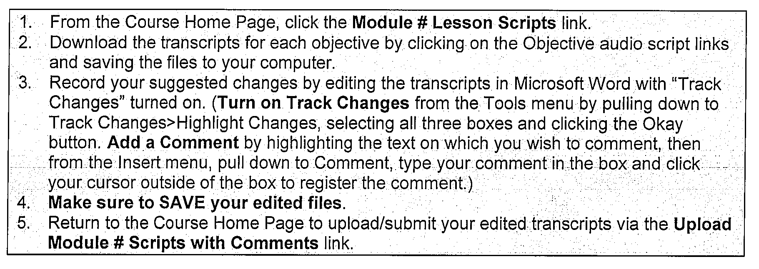
Instructions for Submitting Edited Transcript Files
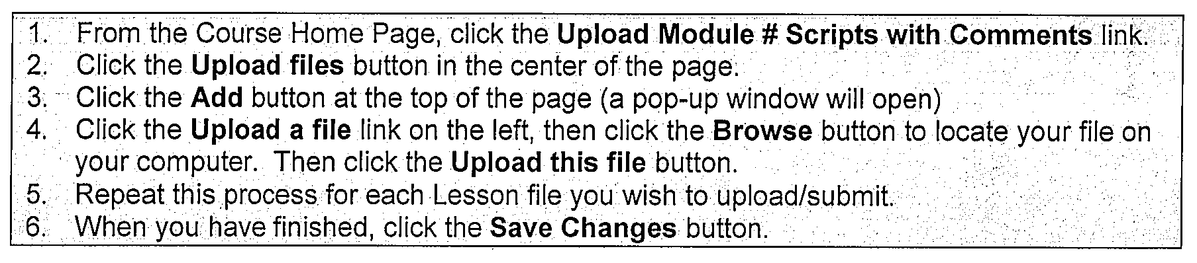
When you have completed the individual feedback process for each of the nine modules, return to the Course Home Page and click on the FINISH HERE: Overall Course Evaluation link. Answer all of the questions and then click the “Submit questionnaire” button. NOTE: Clicking the “Save” button will NOT submit your answers – it will only save a partially-completed questionnaires. You must click the Submit button to record your responses.

QUESTIONS??
Please Contact:
Chelsea Desrochers, Project Manager
Medical Information Systems Unit
617-638-7580

