FLOW CHART: MANUSCRIPT PROCESS

SUBMIT A MANUSCRIPT:
A manuscript may be submitted by the author, the PI, the publisher, or another third party. Third-party submitters must designate an author or PI to serve as a Reviewer for an NIHMS submission. In these cases, the Reviewer will receive notification of the deposit via e-mail.
How to submit manuscripts:
- Sign-in to NIHMS. Click on the “Submit New Manuscript” button.
  - All files associated with the peer-reviewed, accepted manuscript must be submitted.
- Provide Title Information
  - You have the option to manually enter the journal and manuscript title information or find the corresponding citation in PubMed or in your My NCBI Bibliography.
- Add Funding
  - Select all appropriate funding mechanisms (ie. Grants, contracts, intramural) from any of the participating agencies or organizations that supported the work.
- Upload File(s)
  - Upload the manuscripts material, including all figures, tables, supplemental files, and so on as applicable.
- Review the Uploaded File(s)
  - The submission system will generate a “receipt” in PDF format for the uploaded files. The PDF Receipt summarizes the information entered into the system and merges the manuscript’s files into one viewable document. Any supplemental files are represented by placeholders at the end of this receipt. Review this document to ensure that the submission is complete.
- An NIHMSID is automatically assigned to the record once files are provided
- Set Embargo and Reviewer
  - If an author on the paper, indicate the release date when the manuscript will be made publicly available in PubMed Central (PMC) and agree to the Submission Statement.
  - Otherwise, designate an author to review the material, certify compliance with Submitter requirements, and send the submission to the Reviewer for approval (the Reviewer will receive an email inviting him or her to review the material).

INITIAL APPROVAL:
The Reviewer reviews the submission, confirms or adds associated funding, and either rejects or approves the material for processing in NIHMS. If a submission has become stalled in the NIHMS process due to inaction by the assigned Reviewer, another author or PI associated with the NIHMS record can request to take over the Reviewer responsibilities.
How to take over Reviewer responsibilities:
- Sign in to NIHMS
- On your Manuscript List page, click the Stalled tab to view the stalled records currently associated with your account.
- If the record is in a state that requires Reviewer action, a “claim” button will appear in the Status column and lower right-hand corner of the Manuscript Summary page (which is accessible by clicking on the manuscript title). Click on the button to initiate your request.
- On the next page, select “Confirm” to indicate that you are an author (or PI) on the manuscript and would like to take over Reviewer responsibilities.
  - If the currently assigned Reviewers does not act on the submission within one week of your request, the manuscript will be moved to your attention in your Manuscript List to allow you to take action on the submission.
  - If you would like to take over Reviewer responsibilities for a record that is not stalled in the NIHMS process, please contact the Help Desk (https://nihms.nih.gov/db/sub.cgi?page=email&from=grant_suggest&mid=) with your request.

NIHMS CONVERSION:
NIHMS staff reviews the approved files for completeness, and complete submissions are converted to archival XML. The PMC-ready documents (Web and ODF versions) are checked to ensure they accurately reflect the submitted files. Processing time for this step is usually 2-3 weeks but may vary depending on the volume of submissions at a given time. An email notification is sent to the Reviewer when the record is available for final review.

An NIHMS submission goes through various stages of processing. The Status of a submission serves to indicate what action(s) are being taken or are needed. A complete list of statuses is as follows:
Status | What it means
Awaiting file upload | The submitter has started a submission but not complete the file upload or has received a request following approval the PDF Receipt for missing or higher quality files not provided at initial submission.
Undergoing NIHMS review following PDF generation failure | Generation of the PDF Receipt has failed due to data issues requiring intervention by NIHMS staff. Once the issue is resolved, the PDF Receipt will be available to the Submitter for approval or assignment of the designated Reviewer.
Awaiting submitter’s action following PDF generation failure | A notification that the PDF Receipt has failed to generate because of damaged or incompatible files has been sent to the Submitter. He/she should sign in and make the necessary adjustments to the submission.
Awaiting submitter’s initial approval or designation of reviewer | The Submitter has provided files but has neither approved the submission for processing nor assigned a Reviewer to approve the submission.
Awaiting reviewer’s initial approval | A notification that the PDF Receipt is available for review has been sent to the reviewer. He/She should sign in, review the deposit, and sign off on the Submission Statement.
Awaiting submitter action following reviewer’s rejection of deposited files | The Reviewer has rejected the PDF Receipt. The Submitter should come into the system to make any necessary adjustments to the submission before sending it back to the Reviewer.
Undergoing NIHMS review of submission statement rejection | The Reviewer has rejected the Submission Statement. NIHMS staff is reviewing the reason for rejection and will act accordingly, either by removing the submission or contacting the Reviewer.
Undergoing NIHMS review following reviewer’s rejection for lack of funding | The Reviewer has rejected the submission as not having been supported by NIH or a participating funder. NIHMS is reviewing the rejection and will either remove the submission or contact the Reviewer for additional information.
Undergoing NIHMS submission review and file preparation | NIHMS staff if reviewing the deposit to ensure complete files were provided before starting XML conversion.
PMC-participating journal | The submitted manuscript is in a PMC-participating journal. The publisher will supply the manuscript directly to PMC. The NIHMS submission has been blocked from further processing.
Undergoing NLM verification of journal information | This status applies only to submissions from journals that are not already in the NLM Catalog. In these cases, NLM’s catalogers need to create a new record for the journal before processing can continue.
Undergoing conversion to PMC documents | The deposited files are being tagged in XML to create PMC documents (HTML and PDF). NIHMS staff then compares the PMC documents against the original submission to ensure no errors were introduced.
Awaiting reviewer’s final approval | A notification that the PMC-ready documents are available has been sent to the Reviewer. He/she should sign in, review the PMC-formatted version, and either approve or request corrections.
Undergoing revision of PMC documents in response to requested corrections | The Reviewer has requested corrections to the PMC-ready documents. NIHMS staff is addressing the correction request.
Awaiting files from the reviewer OR submitter | A request for missing or higher quality files not caught during initial review or a request for files required to make a Reviewer-requested change to the PMC-ready documents has been sent to the Reviewer or Submitter (as applicable). He/she should sign in and supply the files required to update the material.
Awaiting final citation information | This status applies only to records that do not have final citation information following the Reviewer’s approval of the PMC-ready documents. Final citation information is required to determine the PMC release date. Anyone associated with an NIHMS submission can provide citation information by clicking on the “Provide Citation” button in the manuscript record.
Released to PMC OR Released to PMC (under embargo) | When a submission is queued to go into PMC, it is referred to as being “released to PMC”. This involves sending the PMC documents to the database and any citation information or embargo information to PubMed. A PMCID has been assigned; however, if an embargo has been set, the record will remain in this status with a parenthetical notation that is under embargo.
Available in PMC | PMC users can now access the full manuscript text.
Withdrawn from PMC | The manuscript has been removed from PMC. This is rare and usually occurs because it has been determined that the manuscript does not fall within the scope of the NIH or participating funder’s public access policy and should not have been submitted. The PMCID is no longer valid or compliance purposes.

FINAL APPROVAL:
The Reviewer reviews the PMC-ready documents (Web and PDF versions) and either requests corrections or approves them for inclusion in PMC. Final Approval is required to complete manuscript processing in NIHMS.
- PMC-Ready Documents: After the manuscript content is converted to XML, a web version and PDF are generated for PubMed Central (PMC). These are the PMC documents that will be released to PMC following the approval of the Reviewer and any applicable embargo period.

PMCID ASSIGNED:
A PMCID is assigned by NIH when Final Approval is complete and the manuscript is matched to a PubMed record with complete citation information.
A PMCID is assigned when the following two criteria are met:
- The converted materials have been approved by the Reviewer AND
- The article has been matched to a PubMed record for one of the following:
  - A final print publication date or
  - An electronic publication date for a journal that is an electronic publication only or
  - An electronic publication date for a journal where PubMed has not received the final print publication date within 6 months of the electronic publication date

AVAILABLE IN PMC:
The manuscript is made available in PMC following the publisher-required embargo period (if applicable).

TO BE COMPLIANT:
When and How to Comply
- Accepted for publication
  - There are four methods to ensure that an applicable paper is submitted to PubMed Central (PMC) in compliance with the NIH Public Access Policy. Authors may use whichever method is most appropriate for them and consistent with their publishing agreement.
Version of Paper Submitted | Final Published Article | Final Peer-Reviewed Manuscript
Submission Process | Publisher posts the paper directly to PMC | Papers are required to be submitted via the NIHMS upon acceptance for publication. Publishers, authors or their designee deposit files and the NIHMS converts them to the PMC native format.
Submission Method to Deposit Files | Method A: Some Journals automatically post NIH supported papers directly to PMC  Method B: Authors must make special arrangements for some journals and publishers to post the paper directly to PMC | Method C: Authors or their designee must submit manuscripts to the NIHMS  Method D:  Some publishers will submit manuscripts to the NIHMS  - Awardees are responsible for ensuring manuscripts are submitted to the NIHMS upon acceptance for publication
Approve Submission | Publisher | Author, via NIHMS
Approve PMC web version | Publisher | Author, via NIHMS
Responsible Party | NIH awardee | NIH awardee
To cite papers, from acceptance for publication to 3 months post publication | PMCID or “PMC Journal- In Process” | PMCID or NIHMSID
To cite papers, 3 months post publication and beyond | PMCID | PMCID

METHOD A: These journals post the final published version of all peer-reviewed NIH-funded articles available to PubMed Central (PMC) no later than 12 months after publication without author involvement.
- Track the paper and ensure compliance
  - Make sure the journal knows this paper is supported by NIH funding, and falls under the NIH public access policy. [http://publicaccess.nih.gov/submit_process_journals.htm]
  - Upon acceptance for publication:
    - Enter the citation into your Commons-linked My Bibliography as a ‘forthcoming’ paper.
    - To identify the paper as a Method A journal in My Bibliography, use the autofill settings to enter the journal name. (Check the My Bibliography FAQ for detailed instructions.)
    - Ensure your collaborators can also track the paper by suggesting it to your co-authors and the principal investigators (PI) of any supporting awards. Each PI will have to link the paper to their award.
- Link the paper to the published record
  - My Bibliography will link the forthcoming paper to the published record automatically when the paper is published, provided that the forthcoming citation is similar to the published citation. See this FAQ if you need additional assistance.
- Reporting the paper to NIH
  - For Type 5 progress reports, My NCBI will generate a citation in the correct format for you in a PDF report and in the publication section of the Research Performance Progress Report (RPPR). To manually cite the paper on NIH applications, proposals and reports, including renewal applications (type 2s) and biosketches:
    - For papers published more than 3 months before an application, proposal and report is submitted: List the PubMed Central reference number (PMCID) at the end of the full journal
    - For papers in press (often listed as “[epub ahead of print]”), or published within 3 months of when an application, proposal or report is submitted: "PMC Journal - In Process" or the PMCID at the end of the full citation.

METHOD B: These publishers have an agreement with NIH to post individual final published articles in PubMed Central (PMC) on a case-by-case basis. These journals do not automatically post every NIH-funded paper in PMC. Rather, the author can choose to arrange with the journal to post a specific article; this usually involves choosing the journal’s fee-based open access option for publishing that article.
- Track the paper and ensure compliance
  - Awardees using this submission method are responsible for ensuring that the journal posts the article to PMC to be made publicly available no later than 12 months after publication, in accordance with the NIH Public Access Policy. [https://publicaccess.nih.gov/select_deposit_publishers.htm]
    - Enter the citation into your Commons-linked My Bibliography as a ‘forthcoming’ paper.
    - To identify the paper as a Method B, click ‘edit status’ in My Bibliography and select Method B in the popup window. (Check the My Bibliography FAQ for detailed instructions).
    - Ensure your collaborators can also track the paper by suggesting it to your co-authors and the principal investigators (PI) of any supporting awards. Each PI will have to link the paper to their award.
- Link the paper to the published record
  - My Bibliography will link the forthcoming paper to the published record automatically when the paper is published, provided that the forthcoming citation is similar to the published citation. See this FAQ if you need additional assistance.
  - Within three months of publication, your paper must appear in your Bibliography with PMCID to comply with the public access policy. If not, please contact your publisher and ensure they will deposit the final published paper to PMC as soon as possible.
- Reporting the paper to NIH
  - For Type 5 progress reports, My NCBI will generate a citation in the correct format for you in a PDF report and in the publication section of the Research Performance Progress Report (RPPR). To manually cite the paper on NIH applications, proposals and reports, including renewal applications (type 2s) and biosketches:
    - For papers published more than 3 months before an application, proposal and report is submitted: List the PubMed Central reference number (PMCID) at the end of the full journal
    - For papers in press (often listed as “[epub ahead of print]”), or published within 3 months of when an application, proposal or report is submitted: "PMC Journal - In Process" or the PMCID at the end of the full citation.

METHOD C AND D: The author or a delegate deposits the final peer-reviewed manuscript into the NIH Manuscript Submission system (NIHMS). In Method D, the publisher deposits the final peer-reviewed manuscript into the NIHMS. Regardless of who starts and manages the submission process, authors and awardees are responsible for ensuring that the final, peer-reviewed manuscript is deposited into the NIHMS upon acceptance for publication. Steps 1 and 2, described below, need to be completed within 90 days of the article's official date of publication in order to be compliant with the NIH public access policy.
- At the time of acceptance
  - Enter the citation of the paper into your Commons-linked My NCBI account as a ‘forthcoming’ paper.
  - Ensure that the manuscript is submitted to NIHMS, either by your publisher (Method D) or by yourself (Method C). Method C submissions can bestarted from within My Bibliography.
    - Note: If your publisher is on this list (Method D Publishers), they may perform the initial deposit for you. Please confirm the deposit with the publisher as you are still responsible for ensuring the manuscript is deposited. [https://publicaccess.nih.gov/Method%20D%20Publishers]
  - If necessary, manually add the NIHMSID to the corresponding citation in My NCBI bibliography. An NIHMSID is required to show compliance in My NCBI.
- After the manuscript is submitted to NIHMS
  - The assigned author in the NIHMS system must complete the following steps for a citation to be assigned a PMCID:
    - Approve the initial submission for processing in the NIHMS system.
    - Link the paper to all NIH awards that directly supported it. The Principal Investigators of these awards will be contacted by the NIHMS for confirmation, and the citation will appear in their Bibliography.
    - Review and approve the PMC-ready web version for inclusion in PubMed Central after the submitted files have been converted.
      - Note: The assigned author will receive an email notifying him/her when action is required in NIHMS. Any author, or even a Principal Investigator if they are in a position to verify the content, can serve as the assigned author. See this NIHMS FAQ to change the author assignment.
  - My Bibliography will automatically link the forthcoming citation to the published record, and list the PMCID when it is available. A PMCID must be obtained within 90 days of the official date of publication in order to be compliant with the NIH public access policy.
- Reporting the paper to NIH
  - For Type 5 progress reports, My NCBI will generate a citation in the correct format for you in a PDF report and in the publication section of the Research Performance Progress Report (RPPR). To manually cite the paper on NIH applications, proposals and reports, including renewal applications (type 2s) and biosketches:
    - For papers published more than 3 months before an application, proposal and report is submitted:List the PubMed Central reference number (PMCID) at the end of the full journal citation. A PMCID is the only way to demonstrate compliance for these papers.
    - For papers in press (often listed as “[epub ahead of print]”), or published within 3 months of when an application, proposal or report is submitted:provide a valid NIH Manuscript Submission System reference number (NIHMSID) or PMCID at the end of the full citation.

- Reporting to NIH
  - For non-competing continuation awards, use My NCBI to report papers
Public Access Compliance codes in the RPPR and My NCBI report
Compliant | Not Compliant
Complete  N/A (not applicable)  PMC Journal In Process  In process at NIHMS | Non-compliant
    - Sign into eRA Commons.
    - Collaborate with your colleagues to associate publications with NIH awards, and track public access compliance or declare the paper is not applicable. A video overview is available here.
    - Report your papers via the RPPR, or generate a PDF report for the publications section of the PHS 2590.
  - Everywhere else you wish to cite papers you author or arise from your funding, and are subject to the public access policy, including renewal applications (type 2s) and biosketches:
    - Include the PubMed Central reference number (PMCID) at the end of citations.
For papers published more than 3 months before an application, proposal and report is submitted: List the PubMed Central reference number (PMCID) at the end of the full journal citation for the paper in NIH applications, proposals and reports. A PMCID is the only way to demonstrate compliance for these papers.
    - For papers in press (often listed as "[epub ahead of print]"), or published within 3 months of when an application, proposal or report is submitted:
      - When using Submission Method A or B, indicate "PMC Journal - In Process" or the PMCID at the end of the full citation.
      - When using Submission Method C or D, provide a valid NIH Manuscript Submission System reference number (NIHMSID) or PMCID at the end of the full citation. Note, NIH awardees are responsible for ensuring that all steps of the NIHMS submission process are complete within three months of publication.
      - Note: no special notation is required when manually citing publications that do not fall under the public access policy.
    - Place the Literature Citations in the appropriate location.
      - The appropriate locations for literature citations vary depending on the application type. See the Guide Notice NOT-OD-08-119 for details.

COMPLIANCY CHECKS: MOST HELPFUL LINK OF ALL TIME!!!! [http://www.ncbi.nlm.nih.gov/books/NBK53595/#mybibliography.Managing_Compliance_to_th]
Using the Award display in My Bibliography, eRA Commons users are able to see whether their publications are compliant with NIH Public Access Policy, to start the compliance process and to associate their publications to NIH extramural awards. The aware feature is only available to eRA Commons users who have awarded grants in their portfolios. The eRA arrow icon ( ) verifies than an eRA account has been linked to a My NCBI account.
Checking your Publications Compliance Status
- Go to My Bibliography and click the link “Manage My Bibliography”.
- In the “Display Settings” drop-down menu, select “Award” view. The default sorting option with Award view is “Public Access Compliance”. Click Apply
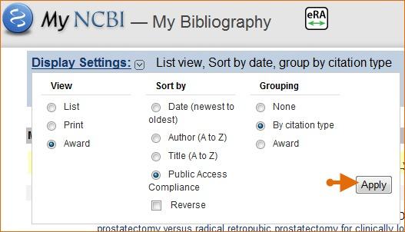
- Each citation will be marked with cues () to indicate the peer-review article compliance status.
  - Journal articles that are compliant with the NIH Public Access Policy are marked with a green dot and have the PubMed Central citation ID (PMCID) number listed.
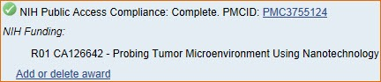
  - Articles newly submitted to the NIH Manuscript Submission system are considered in process and are marked with a yellow dot. Make sure the article has been assigned a NIHMS ID number.
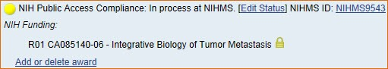

  - A red dot indicates that the article is non-compliant.
    - The compliance process can be started by clicking the red dot or “Edit Status”.
    - NIH funding information can be added to this citation by clicking “Add Award”.
  - A question mark indicates that compliance with the NIH Public Access Policy cannot be determined without additional information.
    - Click “Edit Status” to enter supporting information.
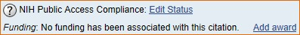
  - Articles that were accepted for publication process prior to April 7, 2008 are not covered by the NIH Public Access Policy. These citations are marked as not applicable (this status is also automatically applied to citation types that are not journal articles; ex: book chapters, patents, presentations).
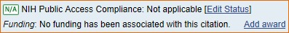

Initiating Public Access Compliance
- Activate the pop-up wizard by clicking either a red dot () or the question mark () or “Edit Status”
- The wizard helps users to being manuscript submission, link to a previously-submitted manuscript, or determine if their citation is exempt from the policy.
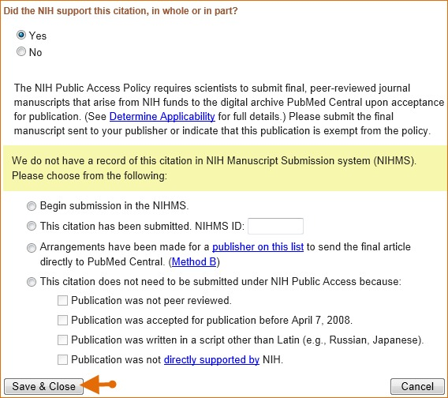

Associating Funding to your Publications
Assign awards is a My Bibliography feature that is used to associate or disassociate grants to citations. There are 3 tabs.
- NIH Awards Tab
  - The “My awards” section provides a list of awards associated to your personal profile.
    - The “Other awards” section displays those awards that are not associated with your personal profile, but have been linked to citations in your My Bibliography
  - To add or delete award associations from either list to your citations, check or uncheck the checkboxes next to an award and save.
    - In some cases, it is not possible to deselect awards through the Assign Awards window.
      - EX: If a grant association was created in the NIH Manuscript Submission (NIHMS) system or if a grant was linked to one of your citations by the grant owner, in both cases the checkbox will be disabled.
- HRA Awards Tab
  - See Above
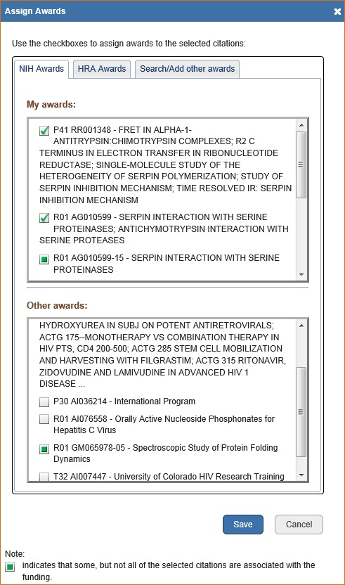
- Search/Add other awards
  - You can search for awards using a grant number, award title, or grantee name.
    - The search box has an auto-complete feature, which provides a list of possible grant numbers or name matches that are displayed as hyperlinks. (screen shot – next page)
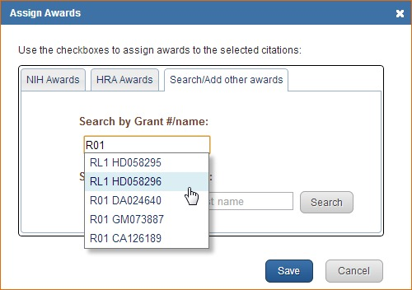
  - Select an award from the list. “Search”
  - A list of grantee names affiliated with the award will be provided. Check the award you wish to have associated with the citation in you’re my Bibliography collection and save.
    - The award will be listed under the citation selected in My Bibliography, and it will be listed in the “Other Awards” section of the Assign Awards window to be added to other citations moving forward.
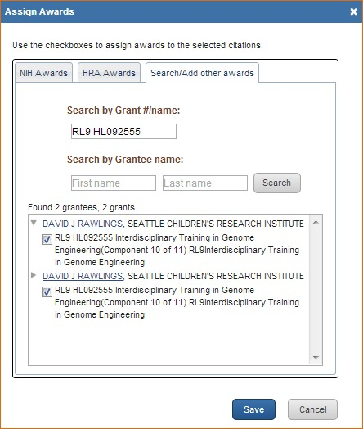
  - My NCBI will notify award owners when citations have been associated to their awards and added to their My Bibliography collection. Once a citation is associated to a grant in My Bibliography or the associate is made via the NIH Manuscript Submission System, the paper-grant association will be included in the PubMed record of that citation, and it will be linked to the grant in the NIH research activities database.
  - My NCBI will automatically add citations to your My Bibliography collection based on new associations made to grant awarded to you. A message will be displayed, which will provide you with a link to review the new citations added.
    - Note that grant owners are able to remove paper-grant associations made by other users. In the case of citations created manually in My Bibliography, only grant owners are able to associate their grants to these citations.
    - The alert message will remain until it is dismissed by clicking on the red X to the right
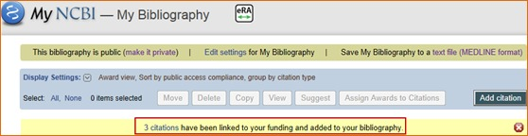
To association multiple citations with awards at once, select the citations you wish to associate to the awards and click “Assign Awards to Citations” button. Select the appropriate tab and choose the pertinent award(s) id(s) from the list presented to you under “My Awards” and save.

Filtering your Citations by Publication Year, Awards, Publication Type and Paper-Grant Associations
- The “Award” view filter provides you with a method to view your award data more clearly by limiting citations results by publication year(s), award number, publication type, and paper-grant associations.
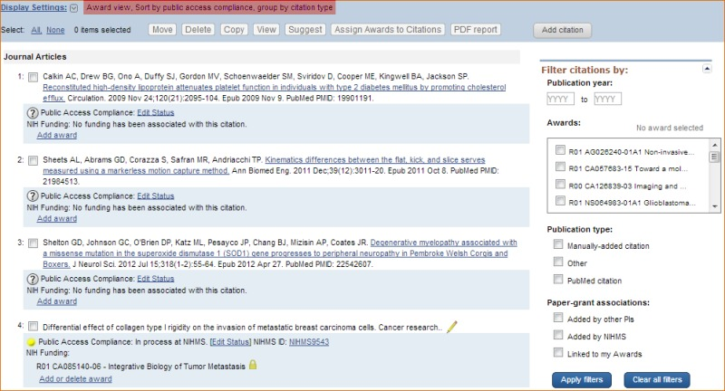
- The Publication year limits your citations results to a range of years or a single year.
- The Awards filter limits your citation results by one or more selected awards. The Awards filter contains all the grants associated with an author’s citations stored in My Bibliography.
- The Publication type limits citation results to either articles found only in PubMed or to citations added manually to My Bibliography.
- The Paper-grant Associations limits citations results to those added through grant linking by other principal investigators (PIs) or those added through the NIH Manuscript Submission (NIHMS) system or to display only citations linked to your awards.

Creating an Award Compliance Report PDF for your Bibliography
- Go to My Bibliography under “Display Settings” and select the Award view
- Select the filter “Linked to my Awards” to limit results to publications linked only to your awards
- Select the citations that you wish to include in your report by checking the boxes next to your publications, or click “All” to select all citations.
- Click “PDF Report”
- On the pop-up window enter your First, Middle, and Last name as well as a starting page number. Click “Download PDF”.
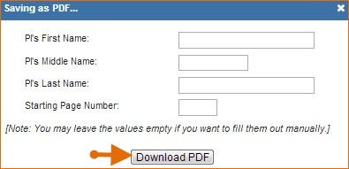
- The resulting PDF will have the information entered in the First, Middle, and Last Name fields on the upper right corner of all the pages included in the report. The compliance status will be shown in the first column and the corresponding citations will be listed in the second column. Pagination will be shown at the bottom of the page.

NIH PUBLIC ACCESS APPLICIABILITY
The NIH Public Access Policy applies to a manuscript that is:
- Peer-reviewed AND
- Accepted for a publication in a journal on or after April 7, 2008 AND
- Arises from any direct funding from:
  - An NIH grant or cooperative agreement active in Fiscal Year 2008 or beyond
  - An NIH contract signed on or after April 7, 2008
  - The NIH intramural Program
  - OR just arises from an NIH employee
If your publication meets these criteria, you are able to post a paper to PMC and report to NIH.
If your publication does NOT meet these criteria, it does not fall under the NIH public access policy, and you should report this publication to NIH.

REPORT PUBLICATION TO NIH
- For noncompeting continuation awards, use My NCBI to report publications (use eRA Commons link)
  - Collaborate with your colleagues to associate publications with NIH awards. Publications entered into My NCBI in the non-journal article citation formats will be automatically marked as exempt from public access (not applicable). You can also designate a journal article as not applicable in My Bibliograpy
  - Report your publications via the RPPR, or generate a PDF report for the publications sections of the PHS 2590. These publications will be listed as N/A.
    - NOTE: If an awardee reports a paper in the publication section of a progress report, they are claiming that is directly arises from the award, and that the paper meets the funding criteria of the NIH public access policy.
- Everywhere else you wish to cite papers you author or arise from your funding
  - Provide the full citation

https://nihms.nih.gov/db/sub.cgi?page=faq#steps
https://nihms.nih.gov/db/sub.cgi?page=stepbystep
http://publicaccess.nih.gov/
https://publicaccess.nih.gov/submit_process.htm
http://www.ncbi.nlm.nih.gov/books/NBK53595/#mybibliography.Managing_Compliance_to_th

