Name:_____________________
Lung Diagram: Label the following parts: alveoli, trachea, bronchi, bronchioles, diaphragm, lung, mouth, and nasal passage,.
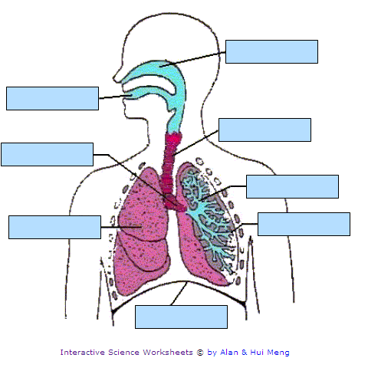
Lung Model
1. Gently push and pull on the handle to move the plastic in and out. What do you observe?

2. Describe what happens to the balloon as the plastic moves in and out. Explain your observations.

3. Which parts of the model represent the lungs, chest cavity, and diaphragm?
Respiratory Rate

Respiration rate is the number of breaths taken each minute (a breath is one inhalation and one exhalation). While watching a clock, count the number of times you breathe in two minutes. Make three trials, and find the average. Divide by two to find the average number of breaths per minute. Record respiration rate on your chart while performing various activities.

